Booking Instructions for Holland America

OneSource/Polar Online

Upon registration your agency was supplied with a login for OneSource which can be shared by all agents. If an agent desires their own login under Travel Hosts send a request to create a login to travelhosts@mvptravel.com . The request must include: Agent full name, agent email address that is NOT currently used in another OneSource account and agency name.

To book, login into OneSource: https://book.princess.com/BookingSystem/login.page

Open Polar Online under the Booking Tools tab and create a booking. When you get to the screen to enter your client names, change the agent name to your AGENCY NAME.
Note: There are only 8 characters available. Abbreviate the agency name if necessary. This is how Travel Hosts identifies the booking agency.
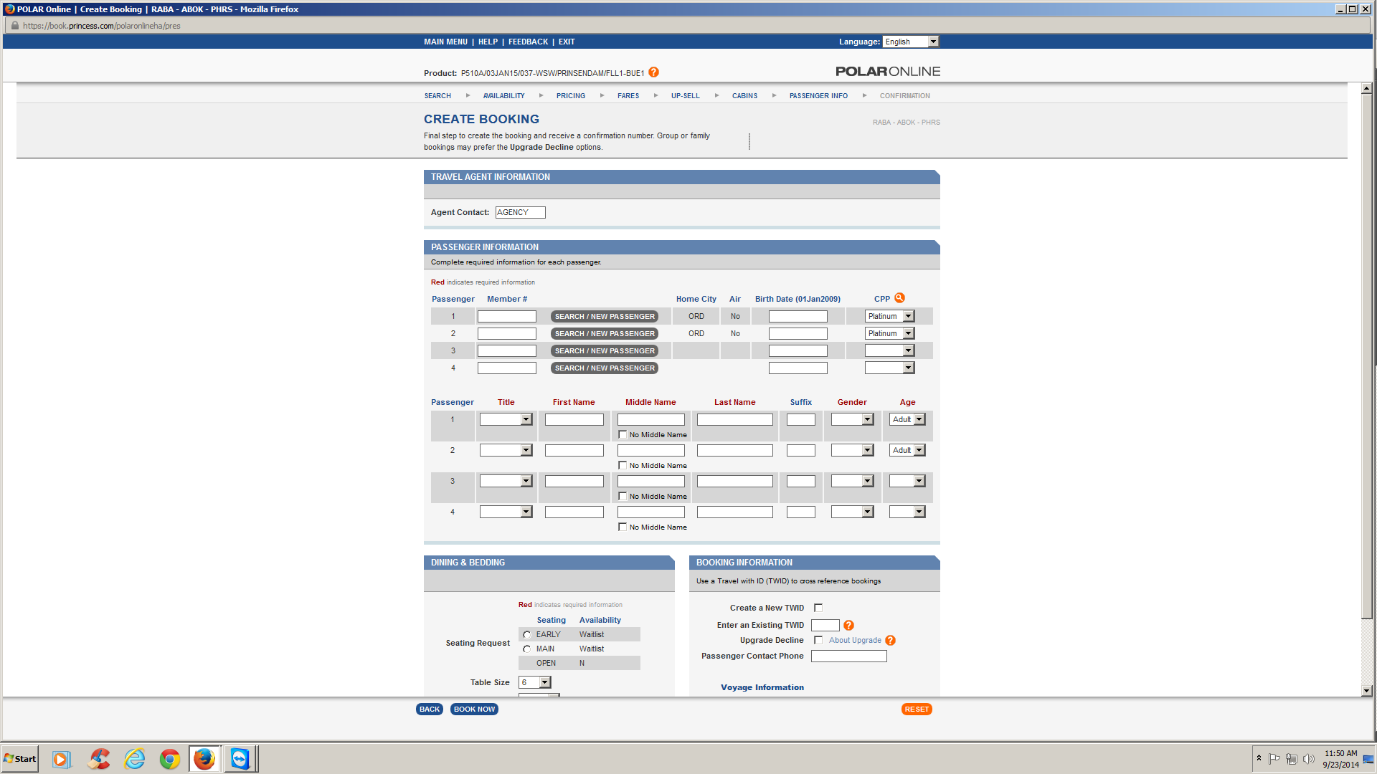

Booking by Phone

Use the Travel Hosts’ phone and CLIA # in place of your agency number and credentials. Identify yourself as an agent of Travel Hosts and give them your agency name to put into the agent name field. Some agencies identify themselves as booking through their “host agency”. If the res agent will not use your agency name, change it in Polar Online yourself after the booking is made.
Make sure a confirmation is sent to travelhosts@mvptravel.com .
Phone: 630.889.9845
CLIA: 00441243

Booking in Sabre Cruises

Your agency was supplied with login information for Sabre Cruises. This login is shared by all agency personnel. PCC for Travel Hosts is A18F.
Complete the booking in Sabre cruises and log into Polar Online to change the agent name.

