For questions and/or help with your Online Check-in forms, please email Holland America Reservations or call 1-800-207-3545. Please be aware that Holland America Line cannot print, email or fax guest's Express Docs or Boarding Pass.
Go to the HAL Travel Agent website: https://gohal.com/
Login with your Travel Hosts’ login for Princess Onesource
(If you do not have a Travel Hosts’ login, email travelhosts@mvptravel.com)

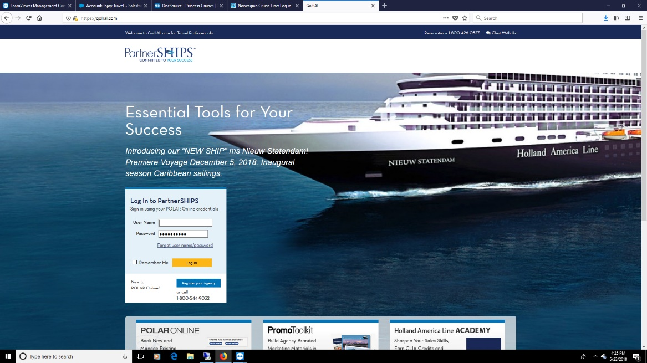

Under the BOOK tab, click check-in
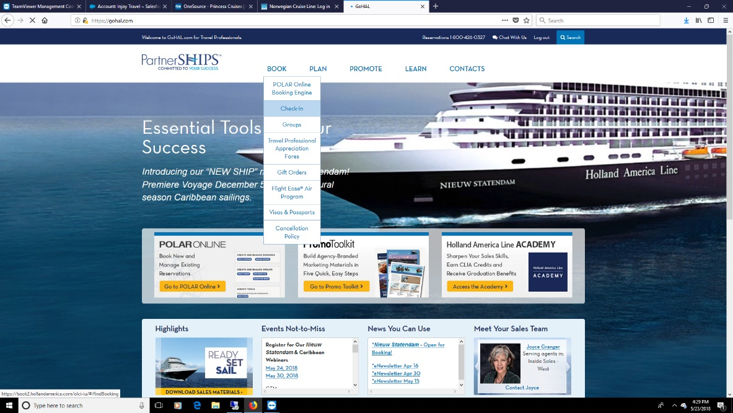

Enter the client booking number and last name and complete the check-in process.

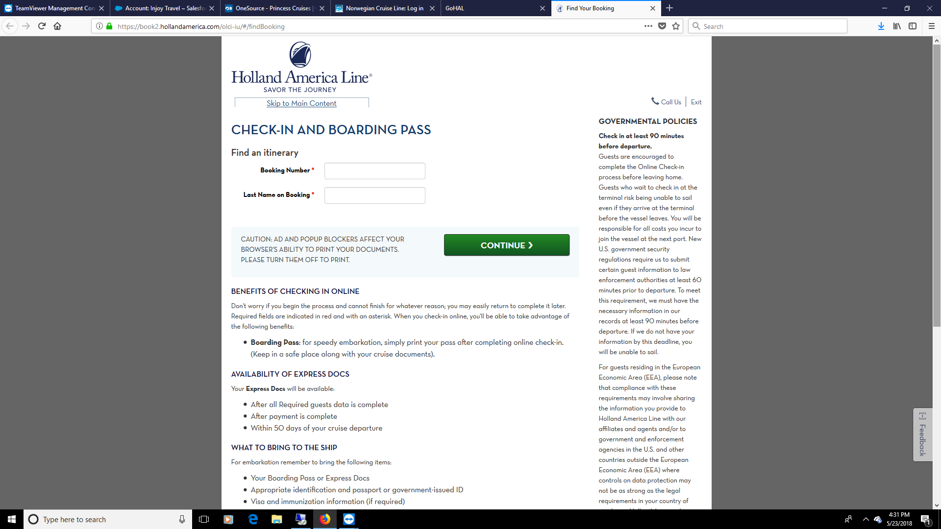

For questions and/or help with your Online Check-in forms, please email Holland America Reservations or call 1-800-207-3545. Please be aware that Holland America Line cannot print, email or fax guest's Express Docs or Boarding Pass.

8/7/2018

