Go to the OneSource/Polar Website
Hover over Booking Tools tab and go to Polar Online
Click on Manage Booking
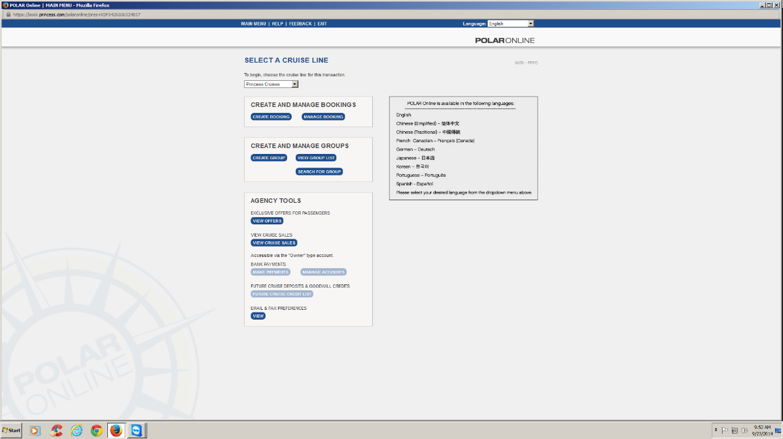

Click on Boarding Pass Status
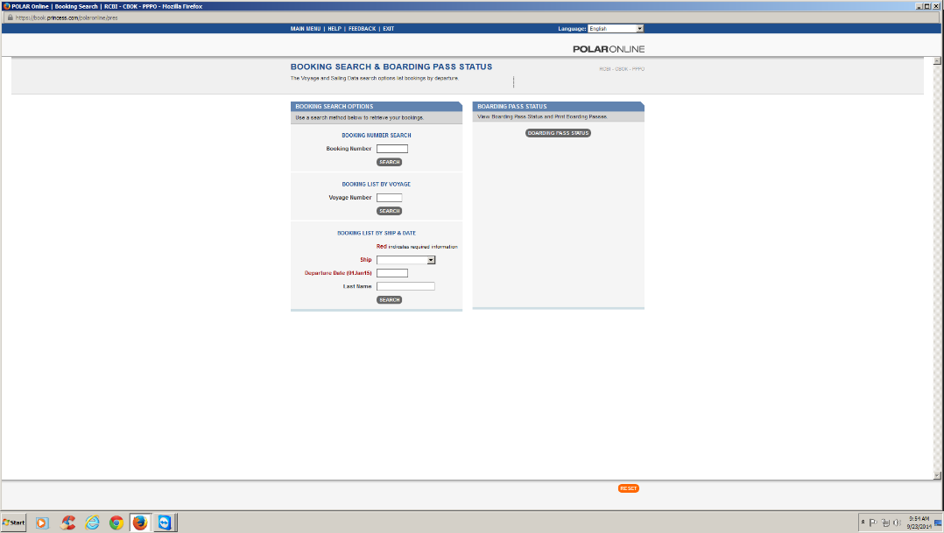

Find your client’s booking in the list, scroll down and print their boarding passes.

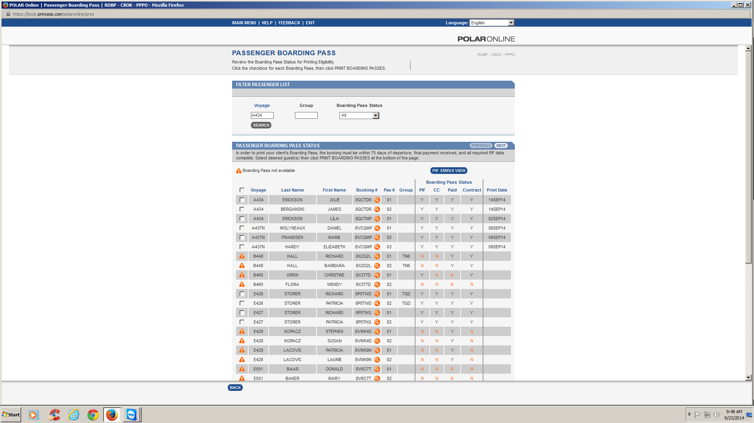

8/7/2018

