5.0

5.1 HOW TO BOOK NCL THROUGH TRAVEL HOSTS

Follow the steps below to make a reservation through Travel Hosts

To book online with NCL:

- Log into the NCL Travel Agent Website WITH YOUR TRAVEL HOSTS’ LOGIN. (Click on link below)
NCL TRAVEL AGENT SITE

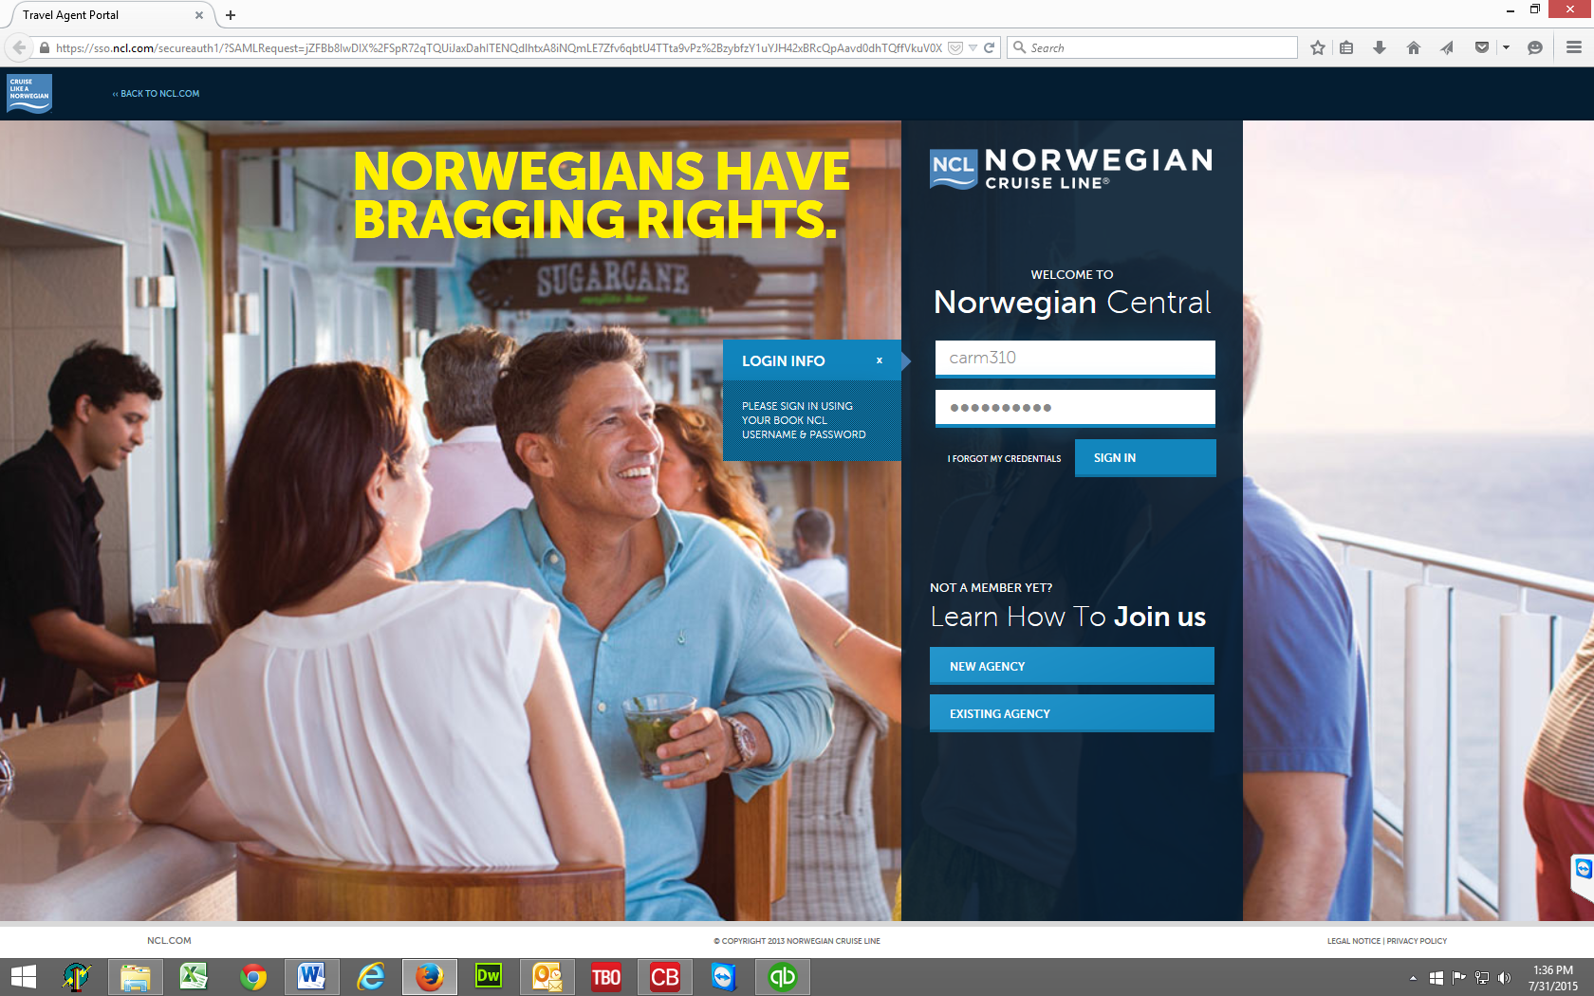

- Once you are in the website, you can book new reservations, manage existing reservations, issue client docs, check in, etc.

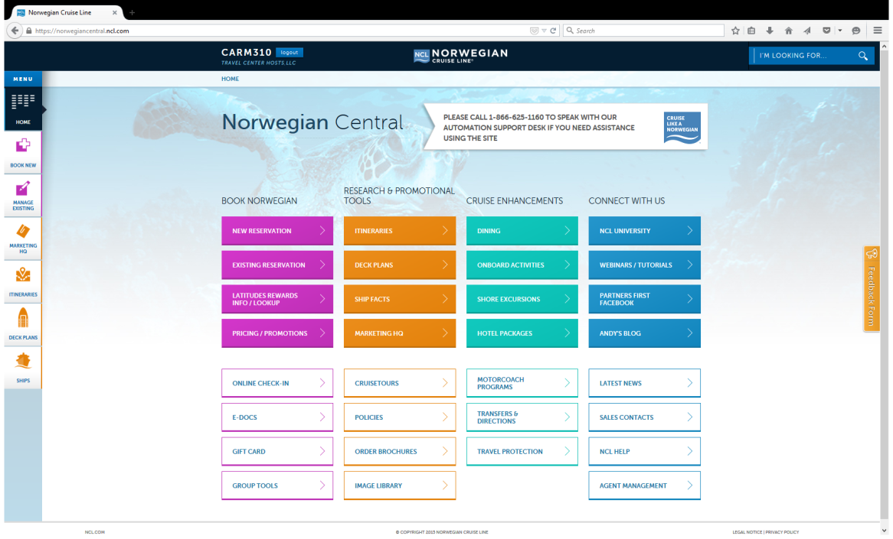
- Click the New Reservation link in the upper left corner of the webpage (next to the NCL logo)

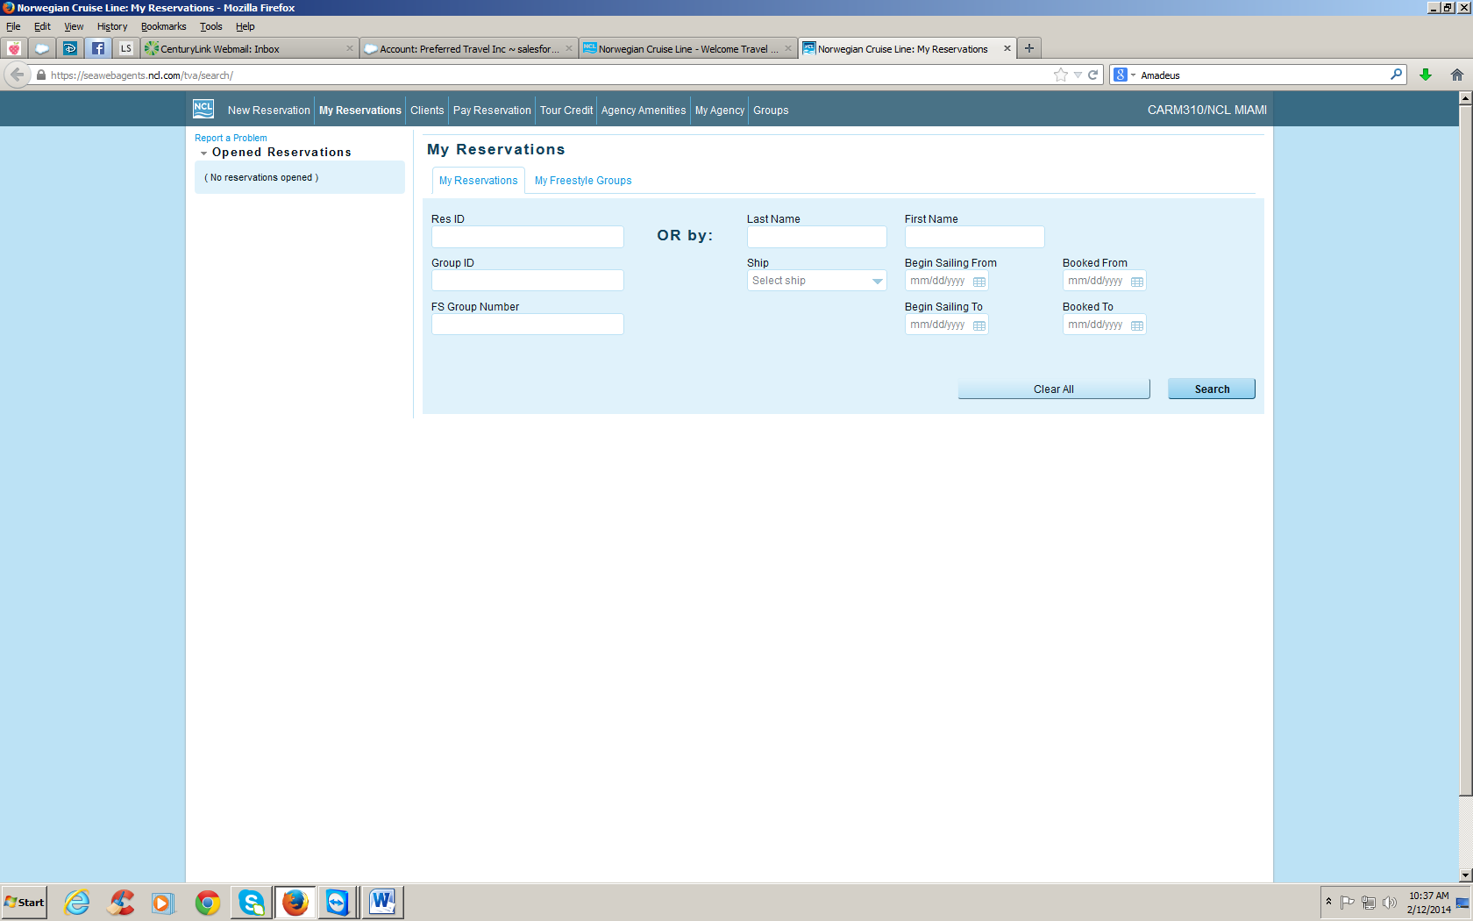

- IMPORTANT NEXT STEPS! Enter the booking phone number for YOUR AGENCY in the Secondary agency box – Enter Your agency booking phone number and click search. Do not enter any hyphens or parenthesis; just enter the 10 numbers running together.

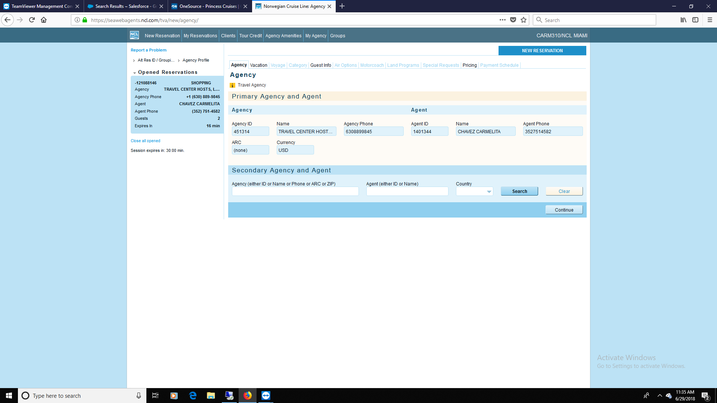

Click the radio button next to your agency name, click the correct booking agent name and click Select (bottom right of the web page) then on next screen click continue.
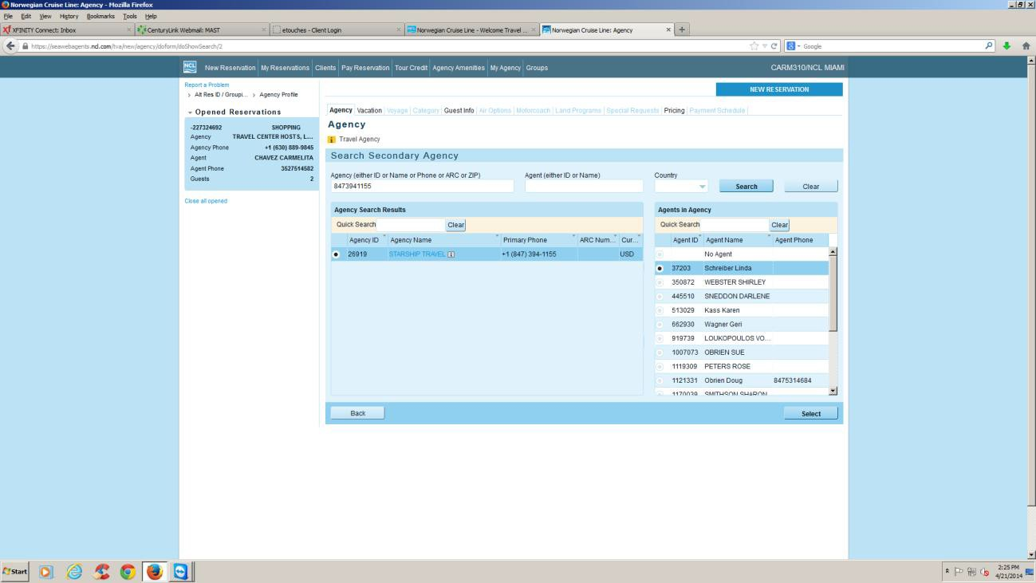

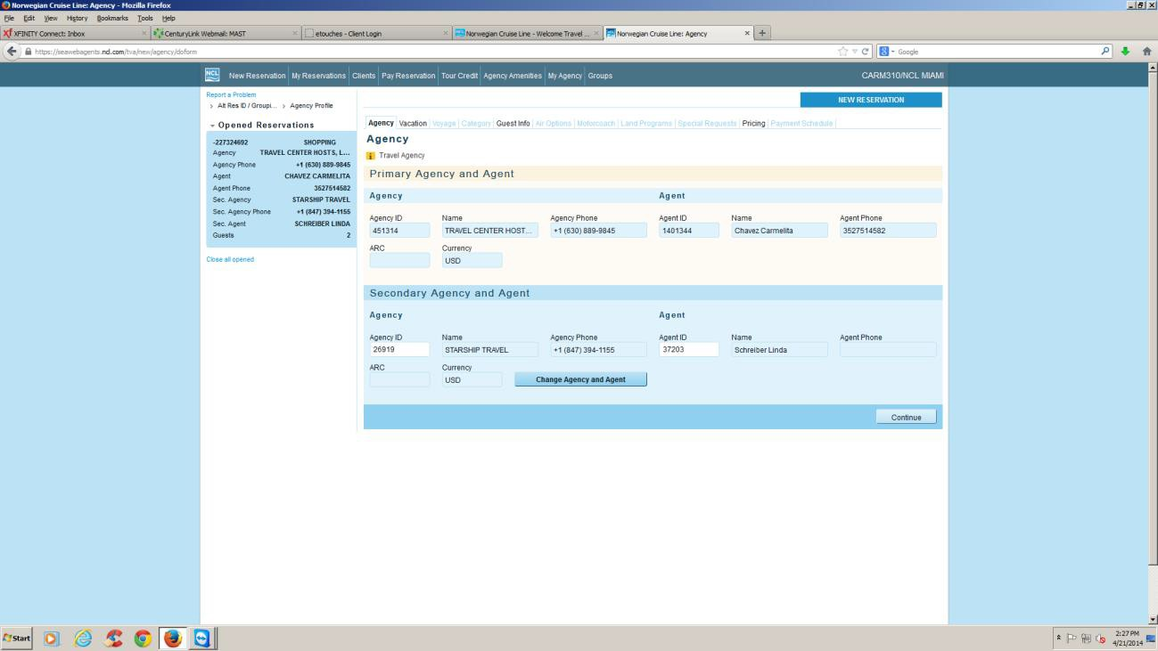

- Notice in the blue box on the upper left corner of the web page your agency and agent name is now listed under the Travel Center Hosts’ name. This is correct and this is how your reservation should look.
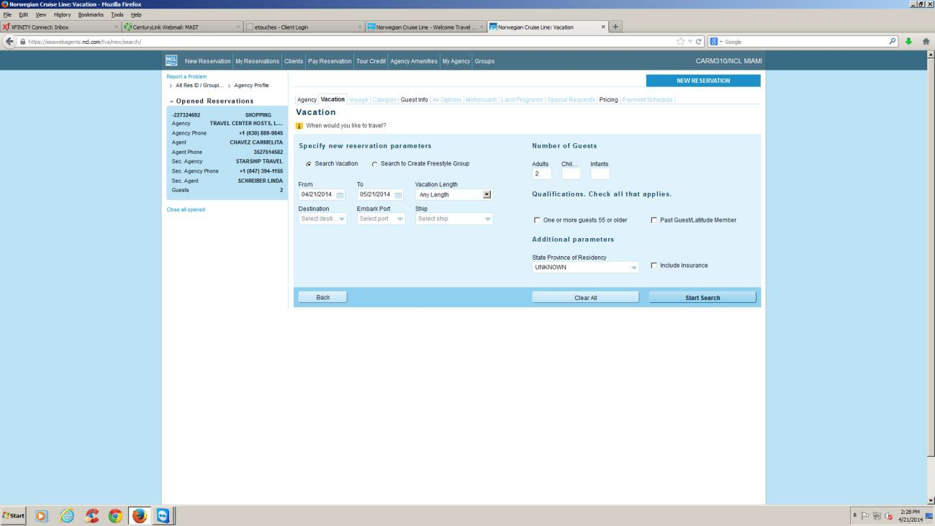

Proceed with your reservation as normal. NOTE: The agent name is Carmelita Chavez because the example was made under the login for Carmelita Chavez. A login has been provided to your agency for the agency. If you would like your own login, email carm@mvptravel.com and one will be provided to you as part of your agency.

TO BOOK BY PHONE WITH NCL:
- Call NCL at 1.866.625.1166 and press 2 for new reservations (press 1 for existing reservations)
- Identify yourself as an agent of Travel Hosts - Phone 630.889.9845 and CLIA 00441243
- Provide YOUR AGENCY phone number for the secondary agency phone field
- Make sure a confirmation is sent to carm@mvptravel.com or travelhosts@mvptravel.com and to your agency email address.

To book on Sabre Cruises:

Enter YOUR AGENCY phone number in the AGENCY BRANCH PHONE box in the bottom middle of the web page (no hyphens or parenthesis) and book as normal. (SEE NEXT PAGE)

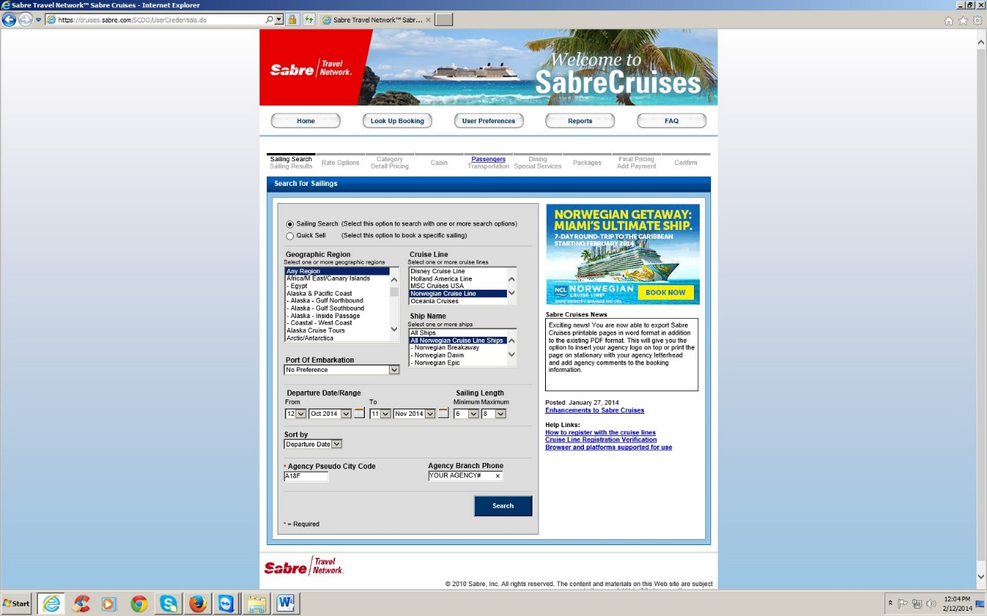

QUESTIONS? Email Carmelita Chavez at carm.chavez@mvptravel.com

