6.1
Disney Travel Agent Cruise Reservations – Online Booking
(Phone booking and Sabre Cruises procedures to follow)
Book as you normally would for a Disney TA online reservation. BE SURE TO LOG IN WITH YOUR TRAVEL HOSTS’ LOGIN*. http://www.disneytravelagents.com/login
*If you do not have your own login go to http://www.disneytravelagents.com/login and register using CLIA 00441243. After you register, Travel Hosts will receive an email to approve your registration. After you are approved you will have access to book Disney Cruise Line through Travel Hosts. PLEASE DO NOT Book any other Disney supplier through Travel Hosts.
NOTE: THIS IS NEW! With one login you can now add numerous agency CLIA/IATA numbers and toggle between them by clicking on the agency link at the top of the page next to your name after you log in.
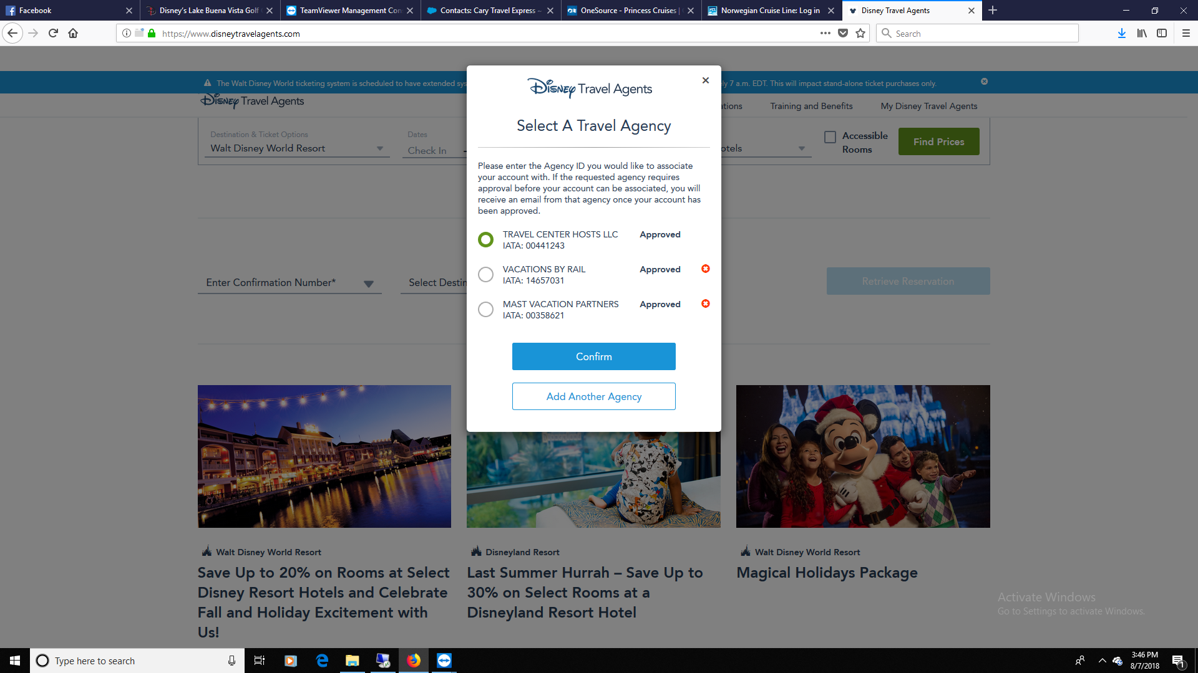

As you proceed through the booking process, choose your name from the agent dropdown list** (Step 4: Guest Information & Payment Travel Agent Information). At the end of your reservation, on the confirmation page you will see your name as the Travel Agent.

**If your name is not in the dropdown agent list (see Screen shot below) call Disney Cruises Line at 800.511.1333 and request your name to be added to the list. Be sure to supply your FULL name. (First and Last names)

Send an agent copy of the confirmation to carm.chavez@mvptravel.com
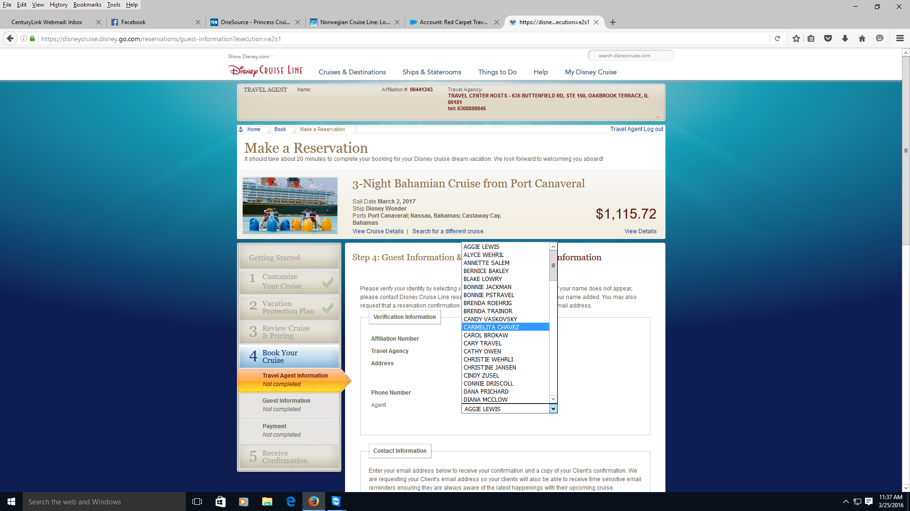

Disney Cruises – Phone Reservation
- Call in your reservation as you normally would - 1.800.511.1333

- Use Travel Hosts’ CLIA 00441243 and phone 630.889.9845

- Ask the Disney res agent to put your name on the reservation as the booking agent

- Ask the Disney res agent to send a confirmation to Travel Hosts’ email carm.chavez@mvptravel.com

Disney Cruises – Sabre Cruises Reservation
1. Log into Sabre Cruises with the sine provided to your agency when you signed up with Travel Hosts.
2. Book as you normally would
3. Send an email to carm@mvptravel.com with a copy of your confirmation or just the booking number and lead client name

